2200031128 CH BHAVANA
HandsOn Task 4 :
Task :
- Implement componentDidMount() hook
- Implementing componentDidCatch() life cycle hook.
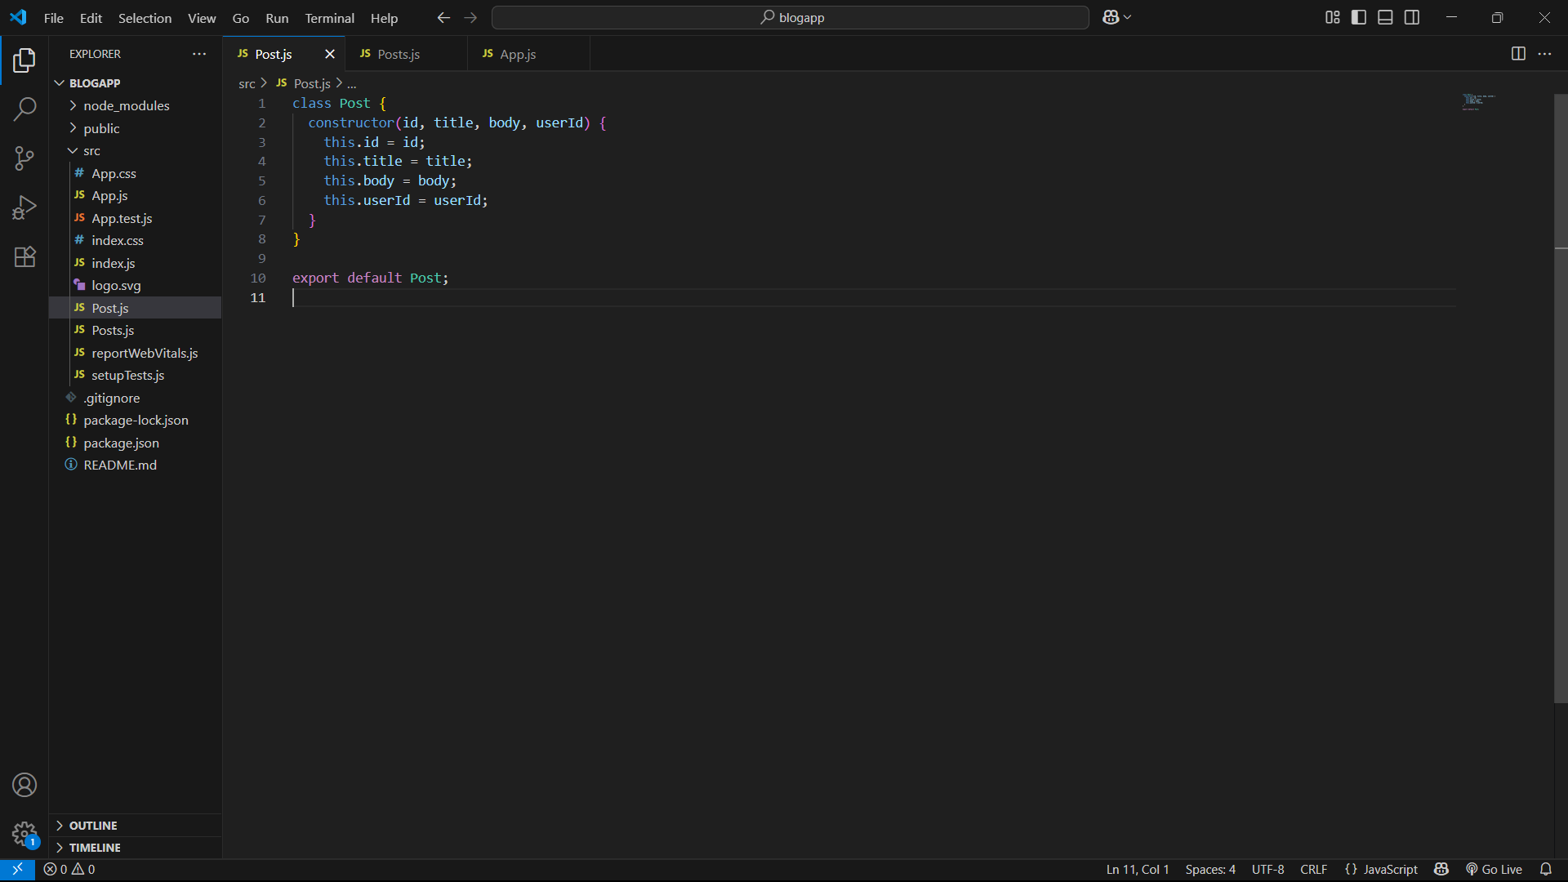
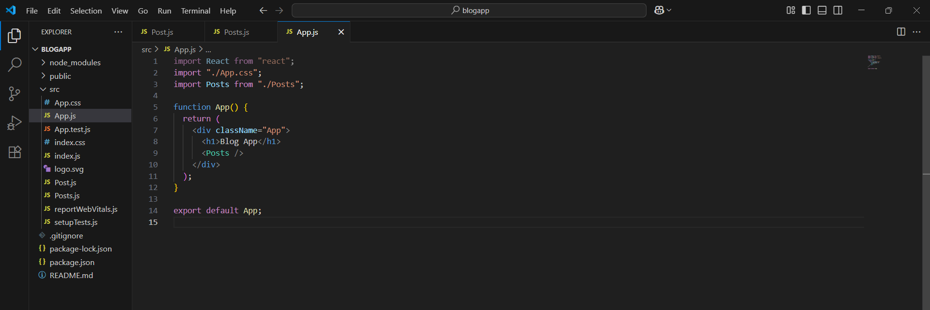

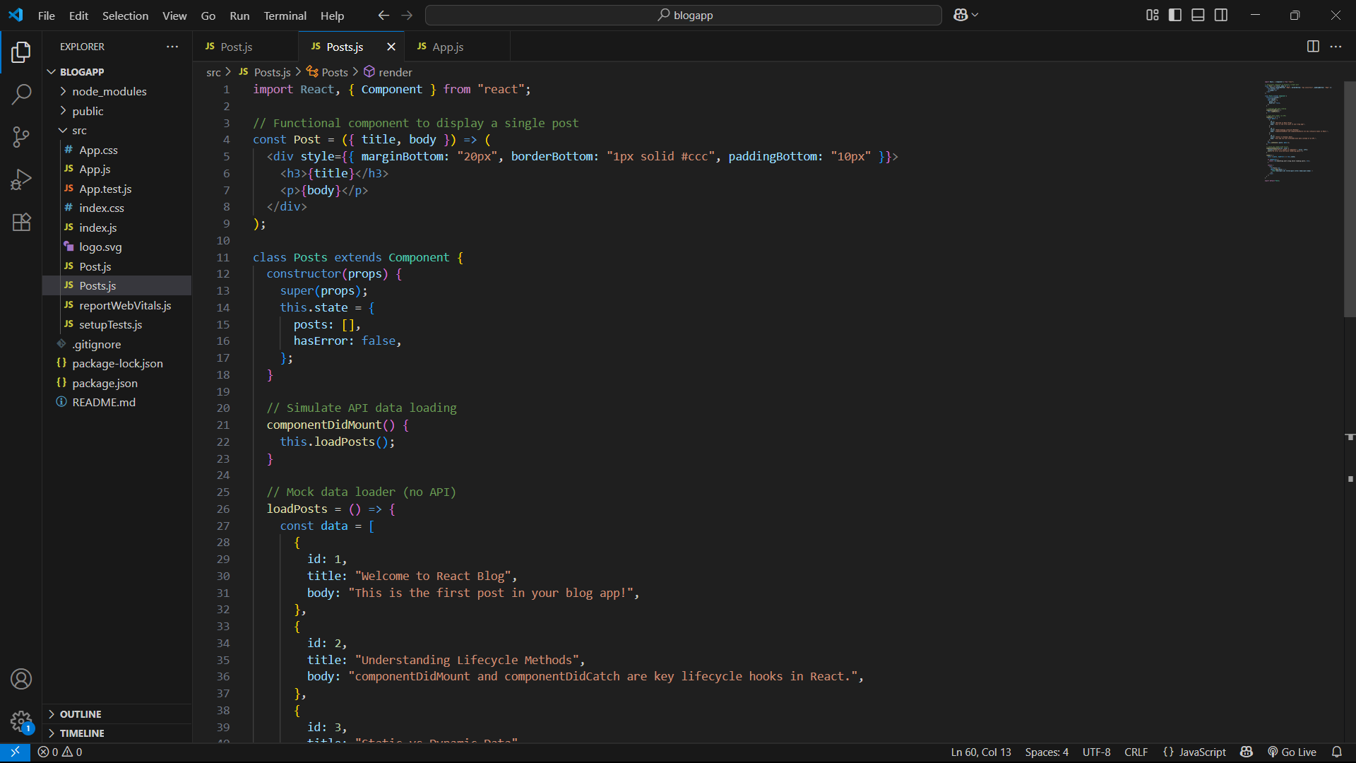
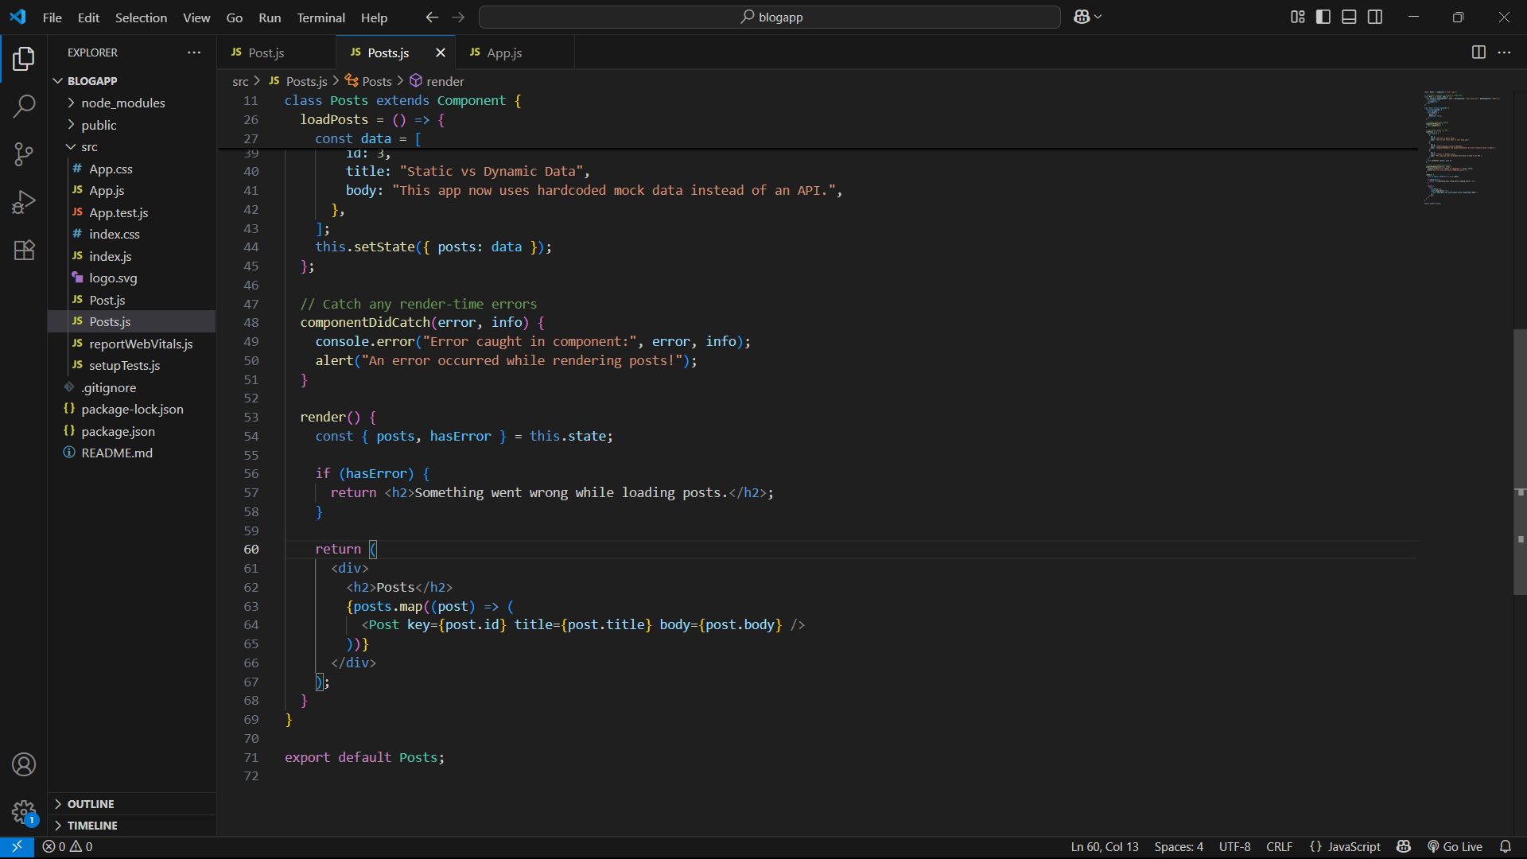
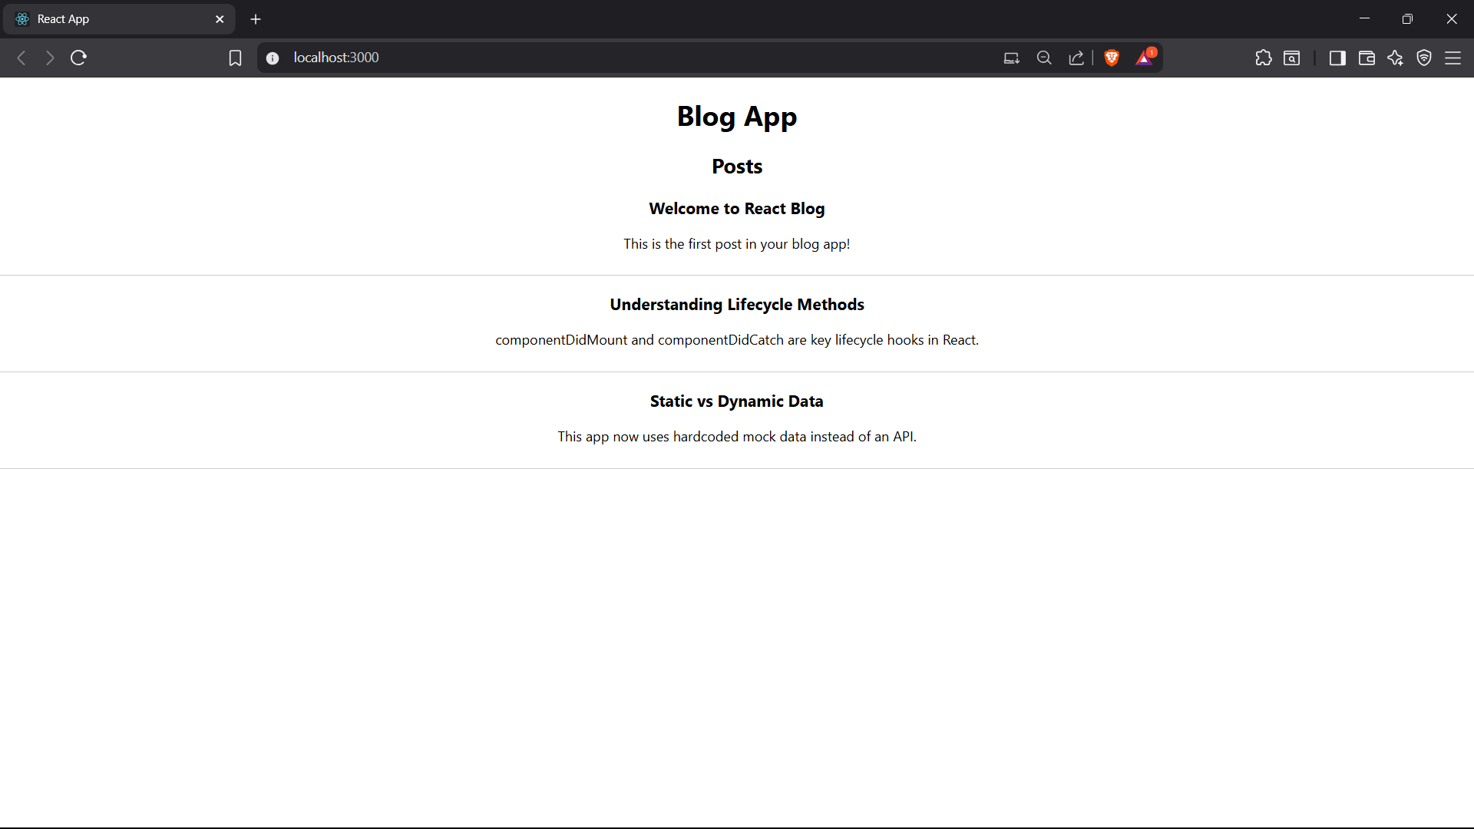
Step 1: Create React App
Step 2: Go into the folder and start the app
Step 3: Create a file Posts.js inside src/
Step 4 Open App.js and replace it
Step 5: Run the app

